JUBILEE 85TH ANNIVERSARY

SUNDAY WEEKLY BULLETIN December 21st , 2014
V. Rev. Archimandrite Eugene N. Pappas

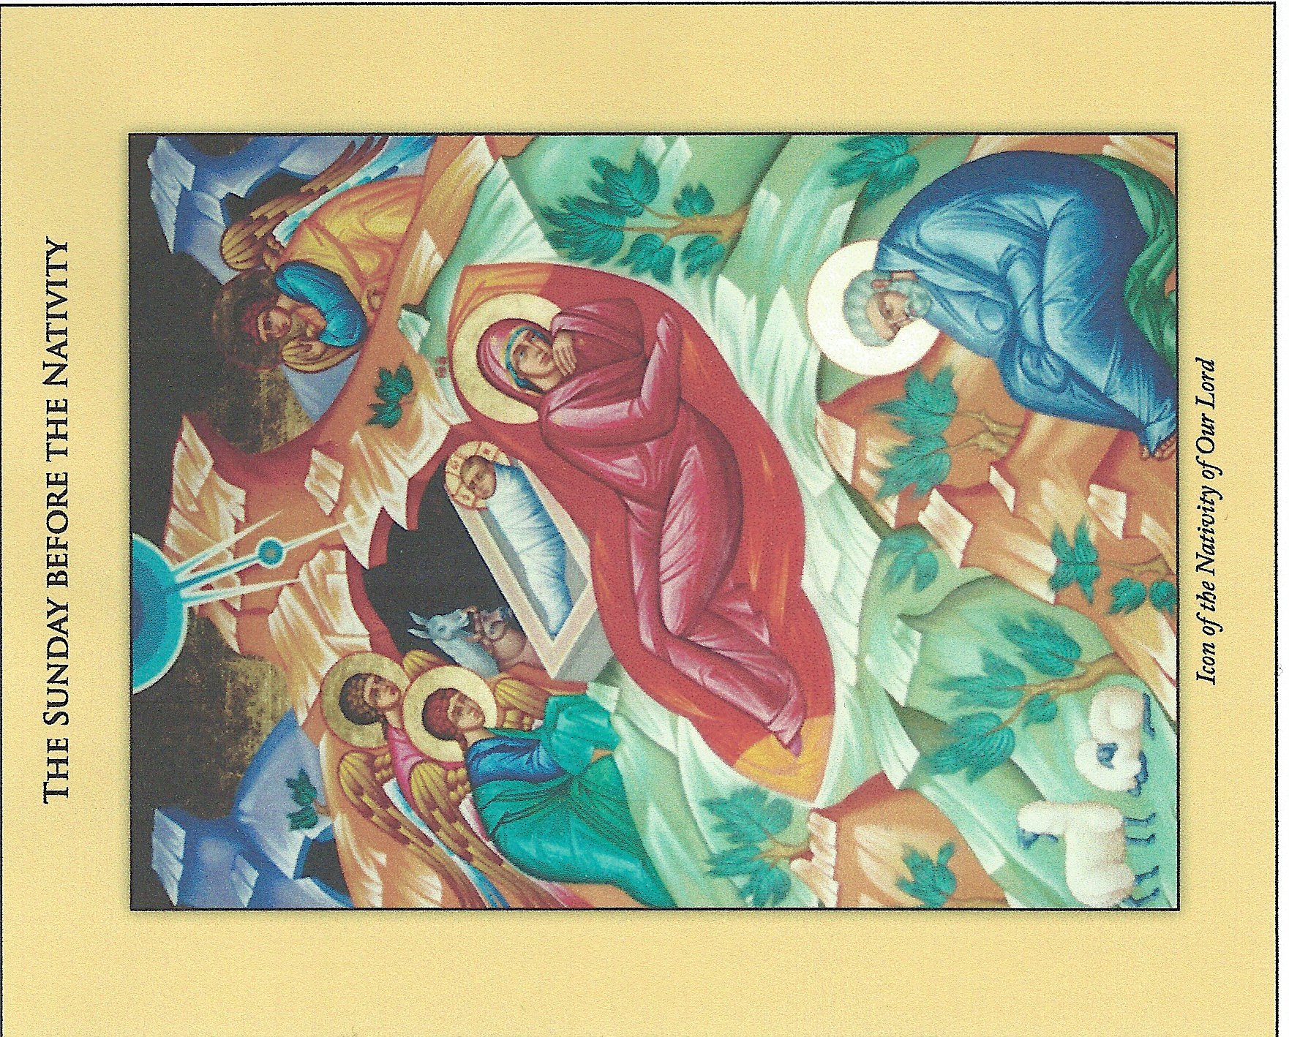

St. Paul's Letter to the Hebrews 11:9-10; 32-40 Prokeimenon. Mode 4. Daniel 3.26,27
Blessed are you, O Lord, the God of our fathers. Verse: For you are just in all you have done.
BRETHREN, by faith Abraham sojourned in the land of promise, as in a foreign land, living in tents with Isaac and Jacob, heirs with him of the same promise. For he looked forward to the city which has foundation, whose builder and maker is God.
And what more shall I say? For time would fail me to tell of Gideon, Barak, Samson, Jephthah, of David and Samuel and the prophets - who through faith conquered kingdoms, enforced justice, received promises, stopped the mouths of lions, quenched raging fire, escaped the edge of the sword, won strength out of weakness, became mighty in war, put foreign armies to flight. Women received their dead by resurrection. Some were tortured, refusing to accept release, that they might rise again to a better life. Others suffered mocking and scourging, and even chains and imprisonment. They were stoned, they were sawn in two, they were tempted, they were killed with the sword; they went about in skins of sheep and goats, destitute, afflicted, ill-treated - of whom the world was not worthy - wandering over deserts and mountains, and in dens and caves of the earth. And all these, though well attested by their faith, did not receive what was promised, since God had foreseen something better for us,that apart from us they should not be made perfect.

Sunday before Nativity
The Gospel of Matthew 1:1-25
The book of the Genealogy of Jesus Christ, the son of David, the son of Abraham. Abraham was the father of Isaac, and Isaac the father of Jacob, and Jacob the father of Judah and his brothers, and Judah the father of Perez and Zerah by Tamar, and Perez the father of Hezron, and Hezron the father of Ram, and Ram the father of Amminadab, and Amminadab the father of Nahshon, and Nahshon the father of Salmon, and Salmon the father of Boaz by Rahab, and Boaz the father of Obed by Ruth, and Obed the father of Jesse, and Jesse the father of David the king.And David was the father of Solomon by the wife of Uriah, and Solomon the father of Rehoboam, and Rehoboam the father of Abijah, and Abijah the father of Asa, and Asa the father of Jehoshaphat, and Jehoshaphat the father of Joram, and Joram the father of Uzziah, and Uzziah the father of Jotham, and Jotham the father of Ahaz, and Ahaz the father of Hezekiah, and Hezekiah the father of Manasseh, and Manasseh the father of Amos, and Amos the father of Josiah, and Josiah the father of Jechoniah and his brothers, at the time of the deportation to Babylon.And after the deportation to Babylon: Jechoniah was the father of Shealtiel, and Shealtiel the father of Zerubbabel, and Zerubbabel the father of Abiud, and Abiud the father of Eliakim, and Eliakim the father of Azor, and Azor the father of Zadok, and Zadok the father of Achim, and Achim the father of Eliud, and Eliud the father of Eleazar, and Eleazar the father of Matthan, and Matthan the father of Jacob, and Jacob the father of Joseph the husband of Mary, of whom Jesus was born, who is called Christ.So all the generations from Abraham to David were fourteen generations, and from David to the deportation to Babylon fourteen generations, and from the deportation to Babylon to the Christ fourteen generations.Now the birth of Jesus Christ took place in this way. When his mother Mary had been betrothed to Joseph, before they came together she was found to be with child of the Holy Spirit; and her husband Joseph, being a just man and unwilling to put her to shame, resolved to divorce her quietly. But as he considered this, behold, an angel of the Lord appeared to him in a dream, saying, "Joseph, son of David, do not fear to take Mary your wife, for that which is conceived in her is of the Holy Spirit; she will bear a son, and you shall call his name Jesus, for he will save his people from their sins." All this took place to fulfill what the Lord had spoken by the prophet: "Behold, a virgin shall conceive and bear a son, and his name shall be called Emmanuel"(which means, God with us). When Joseph woke from sleep, he did as the angel of the Lord commanded him; he took his wife, but knew her not until she had borne a son; and he called his name Jesus.
Sunday before Nativity
Κατὰ Ματθαῖον 1.1-25
Βίβλος γενέσεως ᾿Ιησοῦ Χριστοῦ, υἱοῦ Δαυῒδ υἱοῦ ᾿Αβραάμ.᾿Αβραὰμ ἐγέννησε τὸν ᾿Ισαάκ, ᾿Ισαὰκ δὲ ἐγέννησε τὸν ᾿Ιακώβ, ᾿Ιακὼβ δὲ ἐγέννησε τὸν ᾿Ιούδαν καὶ τοὺς ἀδελφοὺς αὐτοῦ,᾿Ιούδας δὲ ἐγέννησε τὸν Φαρὲς καὶ τὸν Ζαρὰ ἐκ τῆς Θάμαρ, Φαρὲς δὲ ἐγέννησε τὸν ᾿Εσρώμ, ᾿Εσρὼμ δὲ ἐγέννησε τὸν ᾿Αράμ,᾿Αρὰμ δὲ ἐγέννησε τὸν ᾿Αμιναδάβ, ᾿Αμιναδὰβ δὲ ἐγέννησε τὸν Ναασσών, Ναασσὼν δὲ ἐγέννησε τὸν Σαλμών,Σαλμὼν δὲ ἐγέννησε τὸν Βοὸζ ἐκ τῆς ῾Ραχάβ, Βοὸζ δὲ ἐγέννησε τὸν ᾿Ωβὴδ ἐκ τῆς ῾Ρούθ, ᾿Ωβὴδ δὲ ἐγέννησε τὸν ᾿Ιεσσαί,᾿Ιεσσαὶ δὲ ἐγέννησε τὸν Δαυῒδ τὸν βασιλέα. Δαυῒδ δὲ ὁ βασιλεὺς ἐγέννησε τὸν Σολομῶνα ἐκ τῆς τοῦ Οὐρίου,Σολομὼν δὲ ἐγέννησε τὸν ῾Ροβοάμ, ῾Ροβοὰμ δὲ ἐγέννησε τὸν ᾿Αβιά, ᾿Αβιὰ δὲ ἐγέννησε τὸν ᾿Ασά,᾿Ασὰ δὲ ἐγέννησε τὸν ᾿Ιωσαφάτ, ᾿Ιωσαφὰτ δὲ ἐγέννησε τὸν ᾿Ιωράμ, ᾿Ιωρὰμ δὲ ἐγέννησε τὸν ᾿Οζίαν,᾿Οζίας δὲ ἐγέννησε τὸν ᾿Ιωάθαμ, ᾿Ιωάθαμ δὲ ἐγέννησε τὸν ῎Αχαζ, ῎Αχαζ δὲ ἐγέννησε τὸν ᾿Εζεκίαν,᾿Εζεκίας δὲ ἐγέννησε τὸν Μανασσῆ, Μανασσῆς δὲ ἐγέννησε τὸν ᾿Αμών, ᾿Αμὼν δὲ ἐγέννησε τὸν ᾿Ιωσίαν,᾿Ιωσίας δὲ ἐγέννησε τὸν ᾿Ιεχονίαν καὶ τοὺς ἀδελφοὺς αὐτοῦ ἐπὶ τῆς μετοικεσίας Βαβυλῶνος. Μετὰ δὲ τὴν μετοικεσίαν Βαβυλῶνος ᾿Ιεχονίας ἐγέννησε τὸν Σαλαθιήλ, Σαλαθιὴλ δὲ ἐγέννησε τὸν Ζοροβάβελ,Ζοροβάβελ δὲ ἐγέννησε τὸν ᾿Αβιούδ, ᾿Αβιοὺδ δὲ ἐγέννησε τὸν ᾿Ελιακείμ, ᾿Ελιακεὶμ δὲ ἐγέννησε τὸν ᾿Αζώρ,᾿Αζὼρ δὲ ἐγέννησε τὸν Σαδώκ, Σαδὼκ δὲ ἐγέννησε τὸν ᾿Αχείμ, ᾿Αχεὶμ δὲ ἐγέννησε τὸν ᾿Ελιούδ,᾿Ελιοὺδ δὲ ἐγέννησε τὸν ᾿Ελεάζαρ, ᾿Ελεάζαρ δὲ ἐγέννησε τὸν Ματθάν, Ματθὰν δὲ ἐγέννησε τὸν ᾿Ιακώβ,᾿Ιακὼβ δὲ ἐγέννησε τὸν ᾿Ιωσὴφ τὸν ἄνδρα Μαρίας, ἐξ ἧς ἐγεννήθη ᾿Ιησοῦς ὁ λεγόμενος Χριστός.Πᾶσαι οὖν αἱ γενεαὶ ἀπὸ ᾿Αβραὰμ ἕως Δαυῒδ γενεαὶ δεκατέσσαρες, καὶ ἀπὸ Δαυῒδ ἕως τῆς μετοικεσίας Βαβυλῶνος γενεαὶ δεκατέσσαρες, καὶ ἀπὸ τῆς μετοικεσίας Βαβυλῶνος ἕως τοῦ Χριστοῦ γενεαὶ δεκατέσσαρες.Τοῦ δὲ ᾿Ιησοῦ Χριστοῦ ἡ γέννησις οὕτως ἦν. μνηστευθείσης γὰρ τῆς μητρὸς αὐτοῦ Μαρίας τῷ ᾿Ιωσήφ, πρὶν ἢ συνελθεῖν αὐτοὺς εὑρέθη ἐν γαστρὶ ἔχουσα ἐκ Πνεύματος ῾Αγίου.᾿Ιωσὴφ δὲ ὁ ἀνὴρ αὐτῆς, δίκαιος ὢν καὶ μὴ θέλων αὐτὴν παραδειγματίσαι, ἐβουλήθη λάθρα ἀπολῦσαι αὐτήν.ταῦτα δὲ αὐτοῦ ἐνθυμηθέντος ἰδοὺ ἄγγελος Κυρίου κατ᾿ ὄναρ ἐφάνη αὐτῷ λέγων· ᾿Ιωσὴφ υἱὸς Δαυΐδ, μὴ φοβηθῇς παραλαβεῖν Μαριὰμ τὴν γυναῖκά σου· τὸ γὰρ ἐν αὐτῇ γεννηθὲν ἐκ Πνεύματός ἐστιν ῾Αγίου.τέξεται δὲ υἱὸν καὶ καλέσεις τὸ ὄνομα αὐτοῦ ᾿Ιησοῦν· αὐτὸς γὰρ σώσει τὸν λαὸν αὐτοῦ ἀπὸ τῶν ἁμαρτιῶν αὐτῶν.Τοῦτο δὲ ὅλον γέγονεν ἵνα πληρωθῇ τὸ ῥηθὲν ὑπὸ τοῦ Κυρίου διὰ τοῦ προφήτου λέγοντος· ἰδοὺ ἡ παρθένος ἐν γαστρὶ ἕξει καὶ τέξεται υἱόν,καὶ καλέσουσι τὸ ὄνομα αὐτοῦ ᾿Εμμανουήλ,ὅ ἐστι μεθερμηνευόμενον μεθ᾿ ἡμῶν ὁ Θεός. Διεγερθεὶς δὲ ὁ ᾿Ιωσὴφ ἀπὸ τοῦ ὕπνου ἐποίησεν ὡς προσέταξεν αὐτῷ ὁ ἄγγελος Κυρίου καὶ παρέλαβε τὴν γυναῖκα αὐτοῦ,καὶ οὐκ ἐγίνωσκεν αὐτὴν ἕως οὗ ἔτεκε τὸν υἱὸν αὐτῆς τὸν πρωτότοκον, καὶ ἐκάλεσε τὸ ὄνομα αὐτοῦ ᾿Ιησοῦν.

AGAPE COFFEE HOUR: Will be hosted by the Greek School Parent Association. Come and join us for coffee and sweets.

WELCOME BACK FATHER EUGENE: who was in Mexico last week for a special service at the Greek Orthodox Cathedral of SANCTA SOPHIA in Mexico City. He will relate to use today the spiritual vision and miracles that occurred at the venue OF OUR LADY OF GUADELUPE…. miracles never cease to exist.

PAGEANT: Selected children from our GREEK SCHOOL will present the Annual Christmas Pageant at the conclusion of the Divine Liturgy TODAY. We salute the faculty of our SCHOOL who work so diligently with our youngsters in learning the faith, language, history and culture of OUR PEOPLE! Thank you TEACHERS ALL … Zoe, and Maria .

COMMUNITY CHRISTMAS CARD: Which will be forward to 1,000 homes as an ORTHODOX CHRISTIAN greeting for the Holy Nativity may be inscribed with your name or family name as desired. Please fill out the enclosed form and return it to the Church Office today with your offering of $20.00. (twenty dollars). Santa Claus is making a list and SO ARE WE …. Don’t be left out! Others will be looking for your name too. SUPPORT THE CHRISTMAS CARD DRIVE.

SAVE THE DATE: NEW YEARS’S EVE REVELLION, GALA DINNER/DANCE, Wednesday, December 31st Rosehall, 8:00 P.M. Hosted and SPONSORED BY THE A.H.E.P.A. CONEY ISLAND CHAPTER #200 and the DAUGHTERS of PENELOPE DEMETRA CHAPTER #33. See Flyer. Usher in the New Year 2015 with family and friends here.

PARISH COUNCIL ELECTIONS are taking place today until 3:00 P.M. in ROOM #104 in the School Building. Please exercise your privilege as a steward of the Church to elect our COUNCIL MEMBERS. Best Wishes to all the candidates and the new administration for 2015!

GREEK ORTHODOX CHURCH CALENDARS are mailed to all homes of registered stewards of the PARISH. If you have not received a calendar it may suggest that you are NOT registered with the CHURCH OFFICE as a STEWARD. Please check on your membership. The bi-lingual calendar in ENGLISH and GREEK is equally available in RUSSIAN and ENGLISH for our Ukrainian, Russian, Georgian parishioners. Extra calendars are available upon request of the clergy….. see Father Eugene only!

ALTAR BOY TRIP: Our young lads in the Saint Stephanos Altar Boy Society will be treated to dinner and the movies on TUESDAY, DECEMBER 23rd. The typical treat of Cheeseburgers, fries, chicken fingers, coca - cola, and ice cream sundaes will highlight the menu at a local diner. The UNITED ARTISTS Theater at Sheepshead Bay will feature a special action packed religious movie of Ramses and Moses in ‘EXODUS’. The boys are much deserving for their services each Sunday and Holiday throughout the year.

TOY DRIVE FOR CHILDREN; Please consider purchasing a toy for a BOY or GIRL or BOTH from infancy to 12 years of age for distribution by social services before the Christmas Holy Days! The gifts (ARTS and CRAFTS/ LEARNING GAMES /CARS, PLANES, TRUCKS, DOLLS)may be placed before the Icon of the Blessed Mother UN-WRAPPED. The anonymous gifts must be visible for proper distribution by age and gender accordingly This project has increased year by year and is always a source of blessing to the cheerful GIVER too! The PROJECT TOY GIFT begins TODAY and runs until CHRISTMAS EVE.

NEW YEAR KALANDA will be sung in GREEK next Sunday December 28th , as we herald in the NEW YEAR 2015 ! Be here to celebrate and observe a most happy tradition.

OFFICE RENOVATIONS COMMENCE: After nearly 60 years of use and occasional disregard, the business office and the pastoral study are being brought into the TWENTY-FIRST CENTURY with a total renovation of up to date equipment, machines, furniture and modern out-fitting. The cost of the project is estimated at $55.000. (FIFTY-FIVE THOUSAND DOLLARS) and will surely be an asset to the good functioning of our beloved PARISH. The corridor hallways on the first level of the school building are also being renewed with fresh paint and a change of lighting.

CHURCH RENOVATION PROJECT: We submit ourselves to your generosity and love for your home parish of THREE HIERARCHS to make an offering in any amount for the completion of our renovation plans. Please take a ‘peek’ today and witness the beautiful transformation. Room 104 is temporarily our business office. Stop in, say hello and drop off your much needed contribution , Today!

RADIO MINISTRY: Each Saturday at 1:15 PM Fr. Eugene hosts and produces the radio broadcast MATTERS OF CONSCIENCE NOW IN ITS 15TH YEAR OF BROADCASTING LIVE ON WNYE 91.5 COSMOS FM, with listener telephone participation. Subjects of interest regarding Greek Orthodox theology, faith and practice, as well as secular topics confronting the nation and the world are discussed. Tune in and join the dialogue by calling 718-204-8900. Check our live audio at LIVESTREAMINGPLAYER . The website address. W.W.W.gaepis.org (Click live audio)

MEMORIALS TODAY + THEONE VASSILAKOS & + KONSTANTINOS VASSILAKOS
+ DIAMOND DELPH + ANNA SARRIS
MEMORIAL NEXT WEEK: + + DEMETRIOS KLIARIS

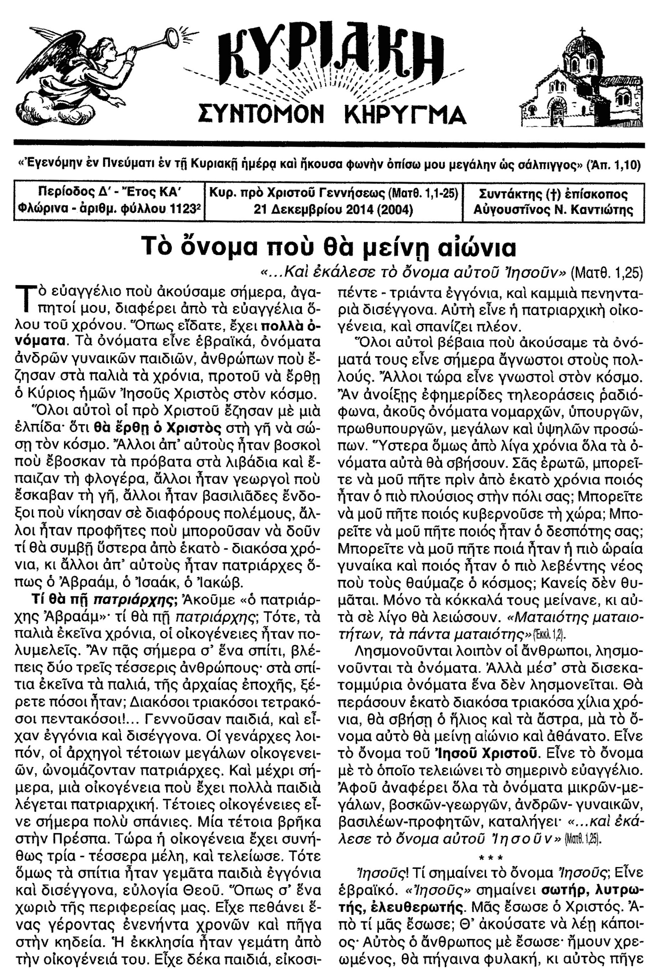

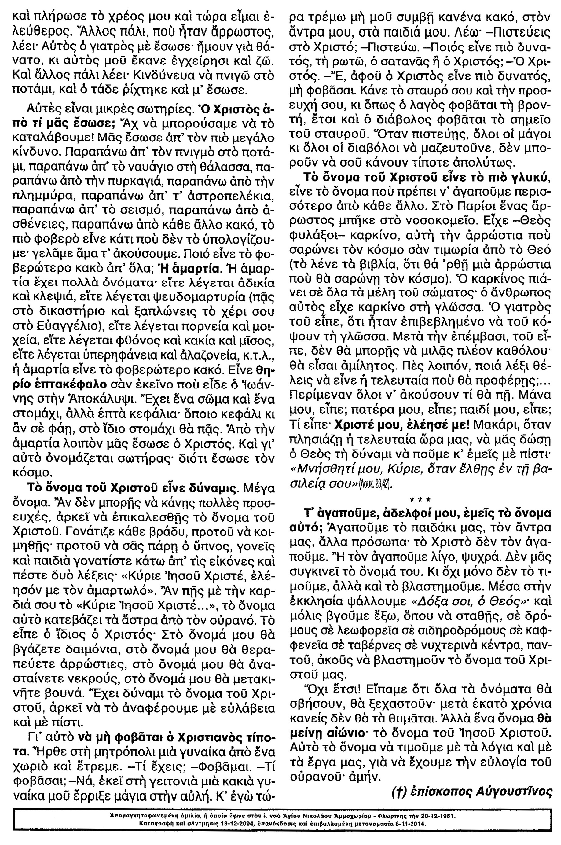

The Lord gives us once again an opportunity to express our solidarity by becoming a supporting and registered member of the parish. We can only urge you to do so because your sustaining membership keeps this parish functioning and responding to the needs of all the faithful. Don’t wait until some insignificant date on the calendar. Register with the Church Office TODAY and garner all the benefits of being a supporter of Christ’s mission on earth.

FAMILY REGISTRATION FOR HUSBAND & WIFE: $275 PER YEAR

SINGLE MEMBERSHIP: $225 PER YEAR

SENIOR CITIZEN INDIVIDUAL MEMBERSHIP: $150 PER YEAR

SENIOR CITIZEN HUSBAND & WIFE MEMBERSHIP: $200 PER YEAR
WE DO NEED YOUR HELP!
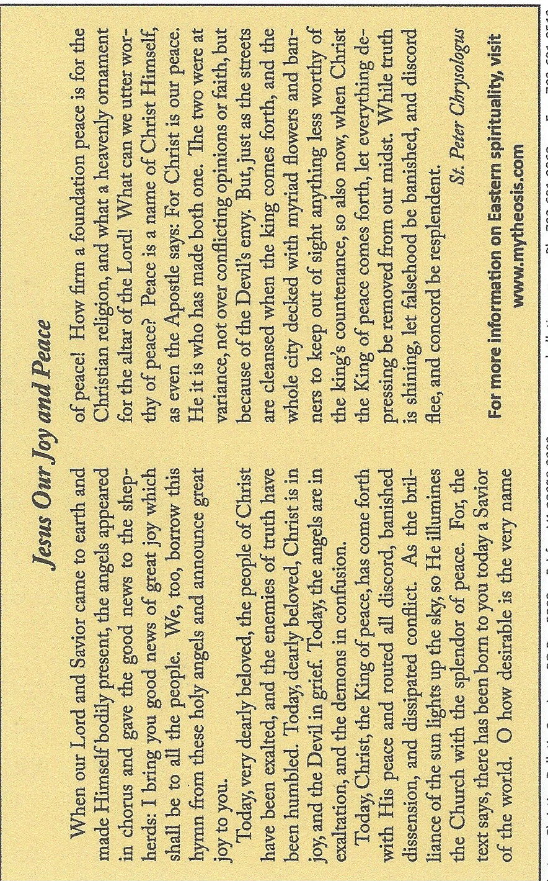
Registering with your local parish is not so much a duty or obligation as it is a PRIVILEGE. By registering and offering your annual stewardship, you become an integral member of the living body of Christ as a faith community. By virtue of your Baptism, Chrismation (Confirmation), and Holy Eucharist (Communion), you claim to be a follower of Christ, a witness for Christ, and a practitioner for Christ. May we ask you then to live up to these promises by making your 2014 commitment TODAY! The benefits you shall receive beyond grace include the satisfaction and knowledge that this Church and community thrives thanks to your outreach.

You are part of the great fresco of faith

WEB-SITE: information is ALWAYS ON LINE ready to see and read. If you submit YOUR E-MAIL address we can forward Bulletin Information to you personally. See :Website: www.threehierarchs.ny.goarch.org

